
Waterstones Internship Programme 2024

Waterstones are offering students in your area an opportunity to participate in a paid internship programme, working in our Bookshops, during summer 2024. This forms part of Waterstones’ strategy to develop stronger partnerships with local communities, regenerate high streets and create more opportunities for those from ethnically diverse or socio-economically disadvantaged backgrounds.

About our internship
- We are offering a paid internship, at our Bookseller or Barista rate of pay.
- The internship will take place after the current academic year, summer 2024.
- We will agree a working pattern, on the basis of 135 hours, over 6 weeks.
- We aim to accept 24 interns in total across England, Scotland and Wales.

We are looking for someone who is open to listening and learning in a fast-paced environment, would feel comfortable in a customer-facing environment and shares the same love for books as we do. You will be supported throughout the internship by a Bookshop Manager, and we want to give you the opportunity to become acquainted with a wide variety of responsibilities, including an introduction to what we love, bookselling!
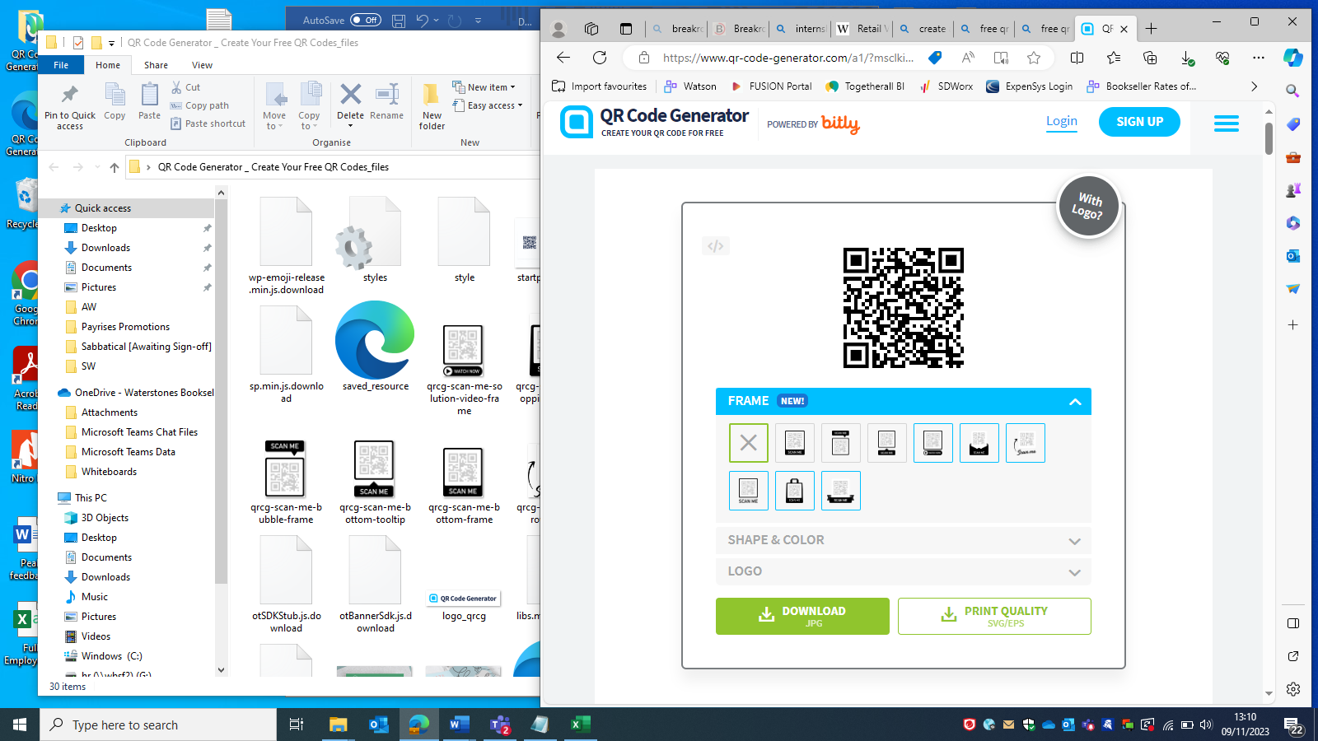

Learn more about what it’s like to be a bookseller by scanning the QR code.

How to apply
We don’t have an application form so to apply, get in contact with us to register your interest; be as creative as you wish and ensure your school endorses your application. We will review all the applications we receive, match them to a suitable host store and invite you in for a chat before letting you know if you have been successful.
Your Waterstones contact is: Paul Lynch Area People Support (paul.lynch@waterstones.com)

