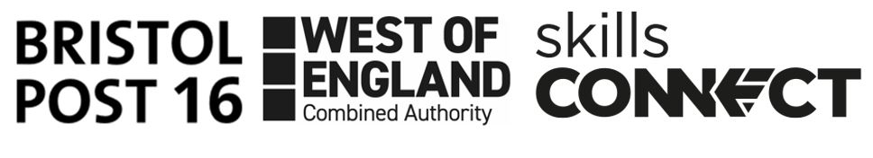

**Website:** wwwbristolesl.com/bristolpost16

**Date 01st February 2024**

**Phone:** 0117 352 5750

**Year 11 Parent/Carer Letter – Life After School**

As your child prepares to enter Year 12 in September 2024, we've gathered essential information to guide them toward exciting opportunities in Education, Employment, and Training. Whether they're considering further education at a local college or 6th form, exploring apprenticeships, or pursuing work-based training programs, we're here to support their journey.

Below, we've outlined key documents your child will need to smoothly transition into their chosen pathway, be it further education, apprenticeships, or a part-time job to boost their finances.

|  |  |
| --- | --- |
| **Documents needed** | **How to get this** |
| **ID** – Ideally a **Birth Certificate** and/or valid **Passport** – this needs to be in date and can take a few weeks to be returned once an application is submitted | * **Birth Certificate**: If you need a replacement and were born in Bristol you can apply online [**get a copy of your Birth Certificate**](http://www.bristol.gov.uk/births-deaths-marriages/get-a-copy-of-a-certificate) * **Passport**: Your young person will need to collect an application form from the Post Office or complete the online application [**Apply for a Passport**](http://www.gov.uk/apply-renew-passport). They will need a birth certificate before applying for this. |
| **Bank Account -** Most banks will offer a 16-year-old a basic current account. It is often easier for them to open an account where their parent/carer already has one. However, with the right ID any bank should be able to help.  This needs to be open before a young person starts college, an apprenticeship or employment. | * Drop into your local bank and ask for the details and key documents needed to open an account. * Make sure you have all the documents needed and if not, make arrangements to get them ASAP. * Then make an appointment at the bank to open an account, this usually only takes 20-30 mins. |
| **National Insurance Number –** This is usually sent to every young person just before their 16th birthday. Cards are no longer sent, just a letter with the full NI number | * Ensure the letter with the NI number is kept in a safe place as this will be needed for any employment. * If your young person has lost the number/letter or did not receive one you can request a new one via [**Get a replacement National Insurance Number**](https://www.gov.uk/lost-national-insurance-number) |
| **Supporting school letter for ID -** If your young person does not have any ID and is struggling to get a birth certificate or passport, then you can request a supporting letter from their last school they attended | * The school staff being asked to provide this should know the young person well and detail the length of time they have known the young person and at which home address. * This can often help when trying to open a bank account, however, cannot be used for passport applications. |
| **CV –** Some employers will ask your young person for an up-to-date CV. This needs to include their education history as well as any work-related experiences. Thisdoes not have to be formal work experience, it could also include projects they have completed in school and any work shadowing, trips to businesses. | * See your school-based Careers Adviser who will arrange a time to see you and pull this document together. * This needs to be stored somewhere safe and accessible, so it can be used after your young person has finished school. * We would advise they email to their personal email account and send a copy of it to a parent/carer. |
| **Email address –** Every young person needs a professional email address. Young people can sometimes have a silly email address that is not suitable for employers to have. | * Create a new one using one of the main accounts such as Hotmail, Gmail, Yahoo etc. * Make sure your young person makes a note of the login details, as these can often be misplaced and can cause issues when trying to retrieve emails from businesses. |
| **Social Media –** Most employers can and will check an applicant’s Facebook/Twitter accounts either before, during or after a person has started working for them. | * Please ensure your young person has an appropriate profile picture and ensure their privacy settings are appropriately set. * Young people should avoid putting any negative/offensive statuses or comments. |
| **Interview Clothes –** Young people should dress appropriately for any college, apprenticeship, or job interview. For most cases it should be formal dress, however there are some cases where a more casual dress is acceptable, so it is best to check with the organisation beforehand. | * If your young person does not have any formal clothing that is suitable, they could attend in their school uniform. This should be clean and smart. * If they need funds to buy interview clothes, please ask them to speak to their school or careers advisor who maybe be able to advise on who can help. * Alternatively contact[**employability@catch-22.org.uk**](mailto:employability@catch-22.org.uk) |
| **First Bus –** Young People (16-21) and students can get up to 20% discount on all tickets across West of England | * Applications can be made online [**Young Person (16-21) & Students | First Bus**](https://www.firstbus.co.uk/bristol-bath-and-west/tickets/ticket-types/young-person-16-21-students) or by going to your nearest bus station. |
| **Colleges** | * Bristol Technology and Engineering Academy 0117 983 8080 * City of Bristol College 0117 312 5000 * Digitech 0117 992 7100 * South Gloucestershire and Stroud College 0800 0567 253 * St Brendan’s Sixth Form College 0117 977 7766 * Bristol Post 16 Website - wwwbristolesl.com/bristolpost16 |
| Please visit Bristol’s Post 16 Website for the latest information and the Post 16 Directory where you can find an extensive list of provisions available in Bristol. | |
| **Information and Advice** | |
| **Bristol Post 16 Career Coaches –** Career support for young people aged 16 or 18 and not in any form of education, employment, or training.  **Princes Trust –** Information and guidance for young people aged 16 or 17 and not in any form of education, employment, or training  **Babbasa -** We inspire and support young people in Bristol to pursue their ambitions through skills training,professional mentoring, events & recruitment support services. | * [**Bristol Post 16**](http://www.bristolesl.com/bristolpost16) **– They are available for face-to-face meetings and are based in the Launchpad in the Galleries every Tues and Friday.** * [**Princes-Trust**](http://www.princes-trust.org.uk/) * [**Babbasa**](http://www.babbasa.com/) |
| **National Careers Service** - provide online and telephone support to young people under the age of 18. | * [**Careers advice - job profiles, information and resources | National Careers Service**](https://nationalcareers.service.gov.uk/) |
| **Mental Health** | * **OTR** - is a mental health social movement by and for young people aged 11-25 living in Bristol and South Gloucestershire. [www.otrbristol.org.uk](http://www.otrbristol.org.uk) * **Kooth –** Online counselling and emotional well-being support that is available to any young person who may be struggling with their mental health. [www.kooth.com/](http://www.kooth.com/) * **Young Minds** - The UK’s leading charity empowering parents and children and young people to improving emotional wellbeing and emotional health.   **Tel: 0808 802 5542** [**www.youngminds.org.uk**](http://www.youngminds.org.uk) |
| **Child Benefit**  **You will usually get a letter to explain how you can continue to receive child benefit if your child remains in education after year 11.**  **Your Child Benefit stops on 31 August on or after your child’s 16th birthday if they leave education or training.** | * Child Benefit can continue if your child stays in approved education or training, **but you must tell the Child Benefit Office.**   <https://www.gov.uk/child-benefit-16-19> |

*\* Please note this is not an exhaustive list and more information can be found on our website*

If you would like to discuss any of the points outlined or would like some help and support, please get in touch with your young person’s school or careers advisor who will be happy to assist with any of the following:

* Careers Guidance
* College application support
* Apprenticeship application support

Please also note that the Local Authority have a statutory responsibility to track every school leaver and their post-16 destination, this may result in the local authority or a member of the post 16 team contacting you/your child between August – October 2024 to confirm their place for September 2024. If no place has been confirmed, then they will contact you throughout the academic year to offer additional help and support.

If your child needs advice or support at that point arrangements can be made to see an advisor or check out the Post 16 Directory/website.

Many thanks

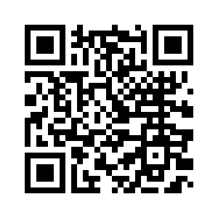Post 16 Team

**Scan this QR code to take you directly to the Post 16 Website:**